**Countdown to Summer**

**Calendar Project**

AFM

Test Grade

Due Monday, April 30th

(8 points off for every day it is late)

***Requirements:***

1. Work out each of the problems attached on a separate sheet of paper.

2) Match the answer with a date on the May Calendar (31 days).

1. Create a calendar (must be in numerical order) and write the problem

with **ALL** work shown on the matching calendar date. **ALL steps** must

be shown (no short cuts). The answer to the problem will be the

date.

4) There will be eight dates left open. You will create your own problems to fill up the 8 dates that are left out. You must have 2 questions from each unit which totals to 6 questions, so the additional 2 can be from a unit of your choice. Make your questions are the appropriate level of difficulty. Place those problems with their corresponding “date” on the calendar.

5) Make sure you provide all work for each problem, including

your created problems.

6.) Digitally submit your work, and calendar. Recommended sites are Google Drive –Spreadsheet or One Drive Spreadsheet as you can easily create a calendar in a spreadsheet. Otherwise, you can use Microsoft Spreadsheet to create the calendar and upload that to Edmodo when all is done. The advantage of Microsoft Spreadsheet is that it can handle Math Text.

***Grading:***

1) Each one of the already created problems will be worth 2 points each.

No work, no credit!

1. Each “created-by-you” problem is worth up to 5 points each, based on the level of difficulty and all 8 must be different in nature. Again, no work, no credit!

3) Neatness and creativity in work and display is worth 14 points.

1. How many ways can 2 students from a group of 5 be lined up for a photograph?

2. Describe **ALL** the translations for the following function: *f(x)* = -2(1/3*x* – 5)4 + 4 .   
 (Use the horizontal stretch/shrink transformation for your calendar date).

3. For the data 2, 5, 6, 9, 12, compute the five number summary to determine what the upper outlier boundary has to be.

4. Simon visits his local fast-food restaurant and orders a burger, a side, a drink and an ice cream. He can choose either a hamburger, or a cheeseburger; he can choose either fries or salad as a side; he can choose one drink from coke, lemonade, or orange; and for his ice cream he can choose either a cone or a sundae. How many different possible meals could Simon choose?

5. Given the following piecewise function, determine what the **end value** of the domain would be for the entire function. **YOU MUST GRAPH THE FUNCTION AS WELL!**

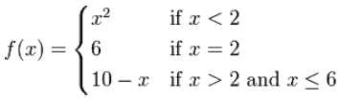

6. Thirty people were asked to state the number of hours they exercise in a seven-day period. The results of the survey are listed below. Make a frequency table and histogram using a bin width of 3 and a y-scale of 1 to display the data. How tall is the tallest bar? **MUST SHOW TABLE & HISTOGRAM ON CALENDAR.**

8, 2, 4, 7.5, 10, 11, 5, 6, 8, 12, 11, 9, 6.5, 10.5, 13, 6.5, 10, 9.5, 4.5, 3.5, 9, 8.5, 11, 11.5, 7, 10, 6, 7.5, 12.5, 13

7. A veterinarian surveys 35 of his patrons.  He discovers that 14 have dogs, 10 have cats, and 5 have fish.  Four have dogs and cats, 3 have dogs and fish, and one has a cat and fish.  If no one has all three kinds of pets, how many patrons have none of these pets?  ( A Venn diagram is helpful!)

8. Given the following toolkit function, describe the transformation used. Just use the numeric answer for your calendar date. **YOU MUST GRAPH EACH FUNCTION ON THE SAME GRAPH!**

9. The shelf life of a particular dairy product is normally distributed with a mean of 12 days and a standard deviation of 3 days. About what percent of the products last 6 days or less? Round your answer to the nearest whole percent for your calendar date!

10. The volume of a particular gas was determined at various pressures. *P* is the pressure (in atmospheres) and is the independent variable on the horizontal axis, and *V* is the volume (in liters) and is the dependent variable on the vertical axis. Find the equation of the curve of best fit. (Round answer constants to *nearest tenth*.) Then, using the regression equation found, estimate *V* if *P* = 2.5*. (*Round your final answer to the nearest whole number for your calendar date.)



11. Evaluate the following piecewise function for *f(5) =*



12. A packet of vegetable seeds has a germination rate of 75%. What is the probability that exactly 17 out of 20 seeds will sprout? Round to the nearest percent.

13. Given the following set of data, find the range:

6, 22, 13, 2, 18, 28, 26, 9, 18

**14.** Water is draining from a tank maintained by the Yorkville Fire Department. Students measured the   
 depth of the water in 15-second intervals and recorded the results in the table below.

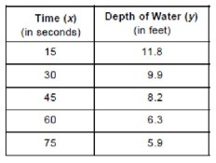

Write the power regression equation for this set of data, rounding all values to the nearest ten thousandth.

Using this equation, predict the depth of the water at 2 minutes, to the nearest tenth of a foot. (Use this answer for your calendar date rounded to the nearest whole number.)

15. In economics, it is useful to consider cases where there are different economic outcomes associated with a specific event. For example, suppose that you ask your father for some extra money. Instead of just giving you the money, he offers to flip a coin. If the coin lands “heads” – you win – and he will give you $20. If it lands “tails”, you lose, and you receive nothing. What is the expected value?

16. Find the mean of the following: **13, 18, 13, 14, 13, 16, 14, 21, 13**

17. What is the y-value of the relative maximum?

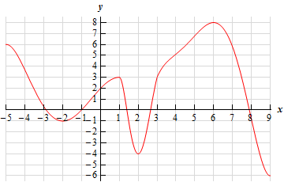

18. What is the **first** number of the last interval where the function is decreasing?

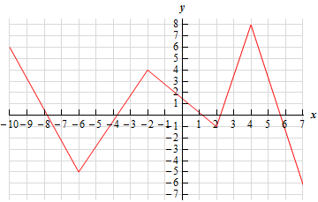

19. The half-life of bismuth 210 is 5 days. How many days it will take the 1.5 grams of

bismuth 210 to decay to 0.3 grams? Round to the nearest whole number.

20. If the average height of a newborn baby is 20 inches with a standard deviation of 2 inches, what would be the length of a baby who is in the top 70%? Round to nearest whole.

21. A reporter from ESPN wanted to interview college students from around North Caroline to ask them their opinions on the NCAA tournament. The reporter went to NC State, ECU, UNC Wilimington, Duke, and UNC Charlotte and sampled 6 students at each school. Describe the sample in this study.

22. 3.5% of US households own cats. How many households do you expect you’ll need to visit to find a cat-owning household? (Round to the nearest whole number for your calendar date.)

23. The probability that Mrs. Goggins will go to the beach this summer is 28%. The probability that Mr. Goggins will go to the beach this summer is 25%. The probability that Mrs. Goggins and Mr. Goggins both go to the beach this summer is 22%. What is the probability that Mr. Goggins or Mrs. Goggins goes to the beach this summer?