Differentiation Rules Integration Rules
$\frac{d}{dx}x^{n}={nx}^{n-1}$ (power rule) $\int{x^{n}dx=\frac{x^{n+1}}{n+1}}+C$
$\frac{d}{dx}\left[u^{n}\right]=nu^{n-1}u^{'}$ $\int{cf\left(x\right)dx}=c\int{f\left(x\right)dx}$
$\frac{d}{dx}\left[c\right]=0$ $\int{\left[f\left(x\right)+g(x)\right]dx}=\int{f\left(x\right)dx+\int{g\left(x\right)dx}}$
$\frac{d}{dx}\left[cu\right]=cu^{'}$ Trigonometric Functions:
$\frac{d}{dx}\left[u±v\right]=u^{'}±v^{'}$ $\int{sin xdx=-cos x+C}$
$\frac{d}{dx}\left[uv\right]={uv}^{'}+{vu}^{'}$ (product rule) $\int{cos xdx=sin x+C}$
$\frac{d}{dx}\left[\frac{u}{v}\right]=\frac{vu^{'}-uv^{'}}{v^{2}}$ (quotient rule) $\int{\tan{x dx} }=-\ln\left|\cos{x}\right|+C$
$g^{'}\left(x\right)=\frac{1}{f^{'}\left(g\left(x\right)\right)}$ where $g(x)$ is the inverse of $f(x)$ $\int{\cot{x dx} }=\ln\left|\sin{x}\right|+C$
Trigonometric Functions: $\int{sec x dx=ln \left|sec x+tan x\right|+C}$
$\frac{d}{dx}\left[sin u\right]=cos\left(u\right)u^{'}$ $\frac{d}{dx}\left[cos u\right]=-sin\left(u\right)u^{'}$ $\int{csc x dx=-ln \left|csc x+cot u\right|+C}$
$\frac{d}{dx}\left[tan u\right]=sec^{2}\left(u\right)u^{'}$ $\frac{d}{dx}\left[cot u\right]=-csc^{2}\left(u\right)u^{'}$ $\int{sec^{2} xdx=tan x+C}$
$\frac{d}{dx}\left[sec u\right]=\left(sec u tan u\right)u^{'}$ $\frac{d}{dx}\left[csc u\right]=-\left(csc u cot u\right)u^{'}$ $\int{csc^{2} xdx=-cot x+C}$
Inverse Trigonometric Functions: $\int{sec x tan xdx=sec x+C}$
$\frac{d}{dx}\left[sin^{-1} u\right]=\frac{u^{'}}{\sqrt{1-u^{2}}}$ $\frac{d}{dx}\left[csc^{-1} u\right]=-\frac{u^{'}}{\left|u\right|\sqrt{u^{2}-1}}$ $\int{csc x cot xdx=-csc x+C}$
$\frac{d}{dx}\left[cos^{-1} u\right]=-\frac{u^{'}}{\sqrt{1-u^{2}}}$ $\frac{d}{dx}\left[sec^{-1} u\right]=\frac{u^{'}}{\left|u\right|\sqrt{u^{2}-1}}$ Inverse Trigonometric Functions:
$\frac{d}{dx}\left[tan^{-1} u\right]=\frac{u^{'}}{1+u^{2}}$ $\frac{d}{dx}\left[cot^{-1} u\right]=-\frac{u^{'}}{1+u^{2}}$ $\int{\frac{du}{\sqrt{a^{2}-u^{2}}}=sin^{-1}\frac{u}{a}+C}$
Exponential & Logarithmic Functions: $\int{\frac{du}{a^{2}+u^{2}}=\frac{1}{a}tan^{-1}\frac{u}{a}+C}$
$\frac{d}{dx}\left[e^{u}\right]=e^{u}u^{'}$ $\frac{d}{dx}\left[a^{u}\right]={\left(ln a\right)a}^{u}u^{'}$ $\int{\frac{du}{u\sqrt{u^{2}-a^{2}}}=\frac{1}{a}sec^{-1}\frac{\left|u\right|}{a}+C}$
$\frac{d}{dx}\left[\left|u\right|\right]=\frac{u}{\left|u\right|}\left(u^{'}\right),u≠0$ $\frac{d}{dx}\left[\log_{a}u\right]=\frac{u^{'}}{\left(ln a\right)u}$ Exponential & Logarithmic Functions:
Properties of Definite Integrals: $\int{e^{x}dx=e^{x}+C}$
$\int_{a}^{a}{f\left(x\right)dx=0}$ $\int_{a}^{b}{f\left(x\right)=\int_{a}^{c}{f\left(x\right)dx}}+\int_{c}^{b}{f\left(x\right)dx}$ $\int{a^{x}dx=\left(\frac{1}{ln a}\right)a^{x}}+C$
$\int_{b}^{a}{f\left(x\right)=-\int_{a}^{b}{f\left(x\right)dx}}$ $\int{\frac{1}{x}dx=ln\left|x\right|+C}$

$$b_{1}$$
FORMULAS FROM GEOMETRY

Triangle  h  $$θ$$  a  b  c  $$h=a\sin{θ}$$  $$A=\frac{1}{2}bh$$  Law of Cosines  $$c^{2}=a^{2}+b^{2}-2ab\cos{θ}$$ |  | Trapezoid  $$h$$  $$b_{2}$$  $$b_{1}$$  $A=\frac{h}{2}\left(b_{1}+b_{2}\right)$  $$b_{2}$$  $$b_{1}$$  $$h$$
Equilateral Triangle  $$s$$  $h=\frac{s\sqrt{3}}{2}$  $$s$$  $A=\frac{s^{2}\sqrt{3}}{4}$  $$s$$ |  | 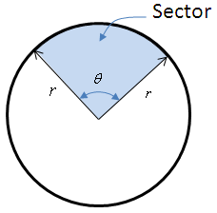  Area of a Sector  $$A= \frac{θr^{2}}{2}$$  $$s=rθ$$  $(θ$in radians)
Circular Ring  $$r$$  $$A=π\left(R^{2}-r^{2}\right)$$ |  | 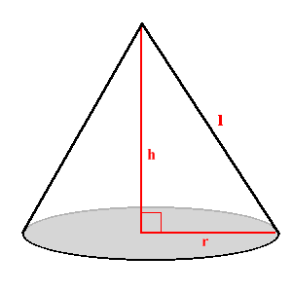  Cone  $$V=\frac{1}{3}πr^{2}h$$  $$L.A.=πrl$$  $$S.A.=πrl+πr^{2}$$
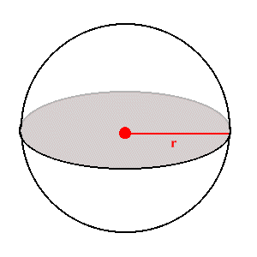  Sphere  $$V=\frac{4}{3}πr^{3}$$  $$S.A.=4πr^{2}$$ |  | 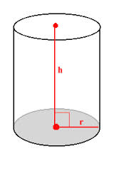  Cylinder  $$V=πr^{2}h$$  $$L.A.=2πrh$$  $$S.A.=2πrh+2πr^{2}$$
Conic Sections

Circle  $$r$$  $${\left(x-h\right)}^{2}+{\left(y-k\right)}^{2}=r^{2}$$  $$A={πr}^{2}$$  $$C=2πr$$ | Ellipse  $$b$$  $$a$$  $\frac{{(x-h)}^{2}}{a^{2}}$+$\frac{{(y-k)}^{2}}{b^{2}}=1$  $$A=πab$$  $$C=2π\sqrt{\frac{a^{2}+b^{2}}{2}}$$
Parabola  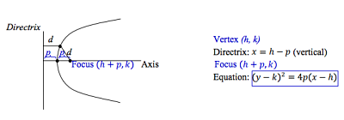  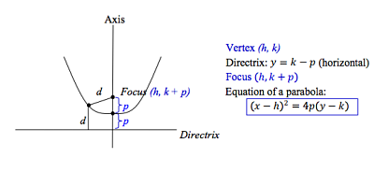 | Hyperbola  