**Precalculus Unit 6 Notes—Double and Half Angle Formulas**

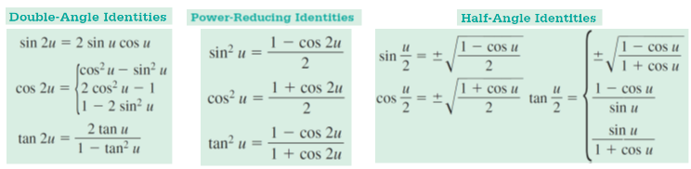

**Example 1 Prove each identify using a sum or difference formula.**

A.  B. 

**Example 2 Solve each equation over .**

A.  B. 

**Example 3 Use half-angle identities to find the exact value of each function.**

A. 

B. 

C. 

D. 

**Example 4 Use double angle identities to find the exact value of each.**

A. 

B. 

C. 

**Example 5 If  and  has its terminal side in the first quadrant, find the exact value of each function.**

**a.  b.  c. **

**Example 6 If  and**  , **find the exact value of each function.**

**a.  b.  c. **