Precalculus Unit 6 Notes—Law of Sines

The Law of Sines—used when given 2 angles and a side OR 2 consecutive sides and a non-included angle (ASA, AAS, or SSA)
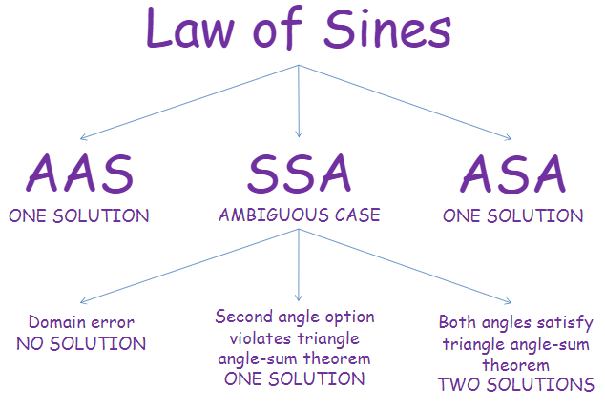
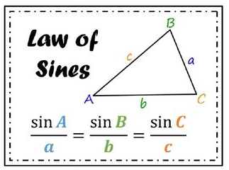

Example 1 Solve $∆ABC:$ A = 50$°$, B = 62$°$, and a = 4.

Example 2 Solve $∆PQR$: P = 36$°$, Q = 48, and p = 8.

Example 3 Solve $∆ABC:$ A = 114$°$, a = 21, and b = 32.

Example 4 Solve $∆ABC:$ C = 97$°$, c = 45, and a = 39.

Example 5 Solve $∆ABC:$ A = 47$°$, a = 20, and b = 12.

Example 6 Solve $∆ABC:$ A = 36$°$, b = 17, and a = 16.

Example 7 A satellite passes over two tracking stations, A and B, 100 km apart. When the satellite is between the two stations the angle of elevation at the stations are measured as 84.5$°$ and 88.2$°$ respectively. What is the distance between the satellite and station A.? How high is the satellite of the ground?

Example 8 To find the distance across a river, a surveyor chooses points A and B, which are 200 ft. apart on one side of
the river. She chooses a reference point C on the opposite side of the river and finds that $<BAC=82°$ and
$<ABC=52°.$ Find the distance across the river.

Precalculus Unit 5 Notes—Law of Cosines and Area of a Triangle

The Law of Cosines—used when given 3 sides OR 2 sides and an included angle (SSS or SAS)
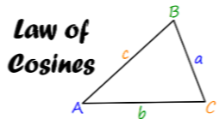
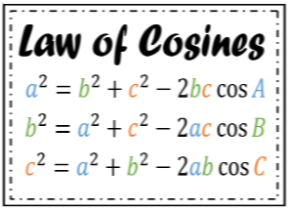

Example 1 Solve $∆ABC:$ a = 10, b = 11, and c = 17

Example 2 Solve $∆ABC:$ A = 35, b = 43, and c = 19

Example 3 A girl is flying two kites at the same time. If the strings are 200 ft and 230 ft long, and the kites are 110 ft
apart, what angle do the strings in her hand make?

Example 4 To find the distance across a small lake, a surveyor has taken the measurements shown. Find the distance
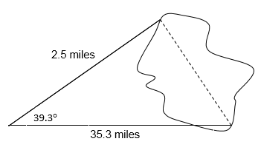
across the lake using this information.

Area of a triangle

$∆$Area = $\frac{1}{2}bc\sin{A=\frac{1}{2}ac\sin{B=\frac{1}{2}ab sin C }}$

Example 5 Find the area of a triangle with sides of length 5 and 12 and included angle 40°.

Example 6 Find the area of triangle ABC to the nearest thousandth if c = 3.2, A = 16°, and B = 31°.

Heron’s Formula

Let $a, b$and $c$ be the sides of $∆ABC$, let $s$ denote the semiperimeter $(a+b+c)/2$.
Then the area of $∆ABC$ is given by Area = $\sqrt{s\left(s-a\right)\left(s-b\right)\left(s-c\right)}$

Example 7 Find the area of triangle ABC to the nearest hundredth if a = 2, b = 7, and c = 8.

Example 8 Find the area of an isosceles triangle with a perimeter of 39 and a base of length 17 inches.

