**Precalculus Unit 6 Notes—Sum and Difference Formulas**

C:\Users\jpowell\AppData\Roaming\PixelMetrics\CaptureWiz\Temp\44.png

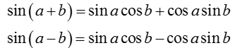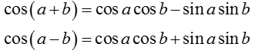

C:\Users\jpowell\AppData\Roaming\PixelMetrics\CaptureWiz\Temp\48.pngC:\Users\jpowell\AppData\Roaming\PixelMetrics\CaptureWiz\Temp\47.png

**Example 1 Use sum and difference formulas to simplify each expression.**

A.sin 22 cos 13   cos 22 sin 13 B. cos ( cos (/4) – sin ( sin (

**Example 2 Prove each identity:**

A.cos (/2 – x) = sin *x* B. sin (/2 – x) = cos *x*

C. sin ( *x* + ) = –sin *x* D. 

**Example 3 Find the EXACT value of each expression.**

A. 

B. 

C. 

D. 

E. 

**Example 4** Find the value of if  ,  ,  , 

**Example 5** Find the value of if  ,  ,  , 