Writing Assignment Example
Convert to Vertex form, describe all transformations and Graph the following (if you use Calculator you must write down the sequences of buttons you pushed.)

$$y=x^{2}+6x+8$$
In order to convert this into Vertex form which is:
$$y=a{(x-h)}^{2}+k$$
You must find a, h, and k. These letters stand for the coefficient in front of x squared (a) this will give the stretch (narrowing), shrink (widening), and reflection of the graph. “h” is x-coordinate of the vertex and also gives the horizontal shift (translation), and “k” is the y-coordinate of the vertex and also gives the vertical shift (translation). We know that a = 1 for the equation in Standard Form. Thus, all that remains is to find the vertex (h,k). We know from class that “h” or x-coordinate of the vertex is actually:
$$\frac{-b}{2a} where a and b are the coefficients in y=ax^{2}+bx+c$$
Thus, the “h” value here is
$$\frac{-b}{2a}=\frac{-6}{2\left(1\right)}=-3$$
Now all that remains is to find the “k” value or y-coordinate of the vertex. We find this by using the -3 as an input value for the equation above to find out the output value which will be “k.”
$$y={\left(-3\right)}^{2}+6\left(-3\right)+8=9-18+8=-1$$
Now we have our a = 1, h = -3, and k = -1, we are now ready to convert to Vertex form.
$$y=1{(x-\left(-3\right))}^{2}-1 = {(x+3)}^{2}-1$$
Which yields:
$$y={\left(x+3\right)}^{2}-1$$
And the conversion is done.

In order to describe all of the transformations in this equation we need a, h, and k again. Having already found them in the last portion we know:
a = 1 tells us that the graph does not reflect, it does not widen, nor does it narrow.
h = -3 tells us that the graph translates or shift horizontally to the left 3 units.
k = -1 tells us that the graph translates or shifts vertically down 1 unit.

This means that the graph will look as follows.

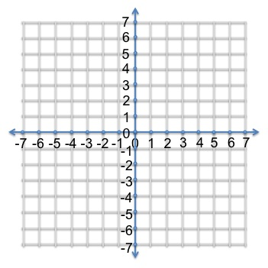
And so we have completed the assignment.

