**Precalculus Unit 5 Notes—Angles and their Measures**

Angles are measured a couple of different ways. The first unit of measurement is a degree in which _______ (degrees) is equal to one revolution. Most likely the reason why we use 360 is from the Babylonians, whose year is based on 360 days. Another unit of measurement for angles is radians. In radians, _____ is equal to one revolution.

So a conversion between radians and degrees $360°=2π$ or $180°= π$

**When converting from degrees to radians: When converting from radians to degrees:**

Multiply your degrees by $\frac{π}{180}$ Multiply your radians by $\frac{180}{π}$

**Ex 1)**  a) Convert $120°$ to radians b) Convert $\frac{4π}{3}$ into degrees.

c) How many radians are in 90°? d) How many degrees are in radians?

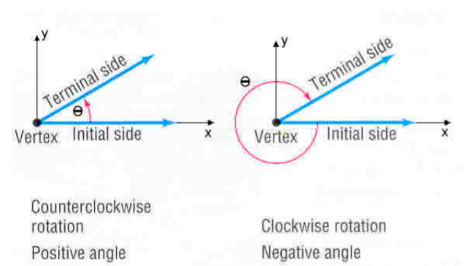We will use________ (theta) to represent an angle’s measurement. In the figure below it describes how you know if an angle is positive or negative.

The __________ of the angle is at the origin of a rectangular coordinate system. The positive x-axis is always where an angle is measured from, and this is called the ______________________. An angle drawn this way is said to be in **standard form**.

An angle that goes counterclockwise is always positive, and clockwise angles are negative.

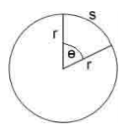

***Arc Length Formula****(Radian Measure)*

The length of the arc between the two lines (intercepted arc) shown with θ. The equation:

*s* = *rθ*

where S is the arc length, r is the radius, and θ MUST be measured in RADIANS!

The θ is also called the central angle.

**Ex 2)** a) Find the length of an arc intercepted b) Find the radian measure of a central

by a central angle of ½ radian in a circle angle intercepting an arc length 18 meters in a

with radius 5in. circle of radius 3 meters.

c) Find the length of an arc intercepted by a central angle of $\frac{120}{π}$ degrees in a circle with a radius of 7ft.

d) Find the perimeter of a 60° slice of a large (7 in. radius) pizza.

e)The running lanes at Emery Sears track at Bluffton College are 1m wide. The inner radius of lane 1 is 33

Looking at the 1st turn in the

track as a semi-circle

meters. If the inner radius of lane 2 is 34 meters, how much longer is lane 2 than lane 1?

***The Pythagorean Theorem***: ONLY works for _______________ triangles!!!

***The 2 Special Triangles***: ___- ___- ___ and ___- ___- ___

***The Nomenclature of the sides***:

***The 6 Trig functions***: (____ ____ ____-____ ____ ____-____ ____ ____)

Sine(θ) = sinθ = _______ Cosine(θ) = cosθ = _______ Tangent(θ) = tanθ = _______

Cosecant(θ) = cscθ = _______ Secant(θ) = secθ = _______ Cotangent(θ) = cotθ = _______

**Ex3)** Find the value of all 6 trig functions for 45°. **Ex4)** Find the value of all 6 trig functions for radians.

**Ex5)** Find the value of all 6 trig functions for  radians. **Ex6)** Find the value of all 6 trig functions for  .

❑

4

3

**Ex7)** Let θ be an acute angle such that  . **Ex8)** Find the other five trig functions of

Evaluate the other trig functions of θ. angle θ given that .

**Ex9)** ΔABC is a right triangle with hypotenuse AB 8 in, and . Draw a diagram, label it, and solve

the triangle. (find the measures of all sides & angles). Write answers in both EXACT form & ROUNDED

to the nearest 10th