Name:_____________________________ CW:__________HW:_________
Unit 6: Trigonometry Part 2
AFM Fall 2017
Date | Day | Topics Covered | Classwork | Assignments
Tuesday  11/28 | 1 | Trig Functions of Any Angle | Practice  Worksheet | 92% | 84% |  | 76% |  | 68% |  | 60%
 |  |  |  | Day 1 Homework
Wednesday  11/29 | 2 | Area of a Triangle | Practice Worksheet | 92% | 84% |  | 76% |  | 68% |  | 60%
 |  |  |  | Day 2 Homework
Thursday  11/30 | 3 | Graphing Sine and Cosine | Practice Worksheet | 92% | 84% |  | 76% |  | 68% |  | 60%
Friday  12/1 | 4 | Review | Quiz | 92% |  | 84% |  | 76% |  | 68% |  | 60%
 |  |  |  | Day 4 Homework
Monday  12/4 | 5 | Graphing Secant and Cosecant | Practice Worksheet | 92% | 84% |  | 76% |  | 68% |  | 60%
 |  |  |  | Day 5 Homework
Tuesday  12/5 | 6 | Equations of Graphs | Practice Worksheet | 92% | 84% |  | 76% |  | 68% |  | 60%
 |  |  |  | Day 6 Homework
Wednesday  12/6 | 7 | Trigonometric Regression | Practice Worksheet | 92% | 84% |  | 76% |  | 68% |  | 60%
 |  |  |  | Day 7 Homework
Thursday  12/7 | 8 | Application Problems | Practice Worksheet | 92% | 84% |  | 76% |  | 68% |  | 60%
 |  |  |  | Day 8 Homework
Friday  12/8 | 9 | Review | Study Guide | 92% | 84% |  | 76% |  | 68% |  | 60%
 |  |  |  | Day 9 Homework
Monday  12/11 | 10 | Test |  | 92% | 84% |  | 76% |  | 68% |  | 60%
 |  |  |  | Finish Review

Lesson 1 Homework
Unit 6 – Trigonometry Part 2
1. Given (-4, 3) is a point on the terminal side of angle θ. Find the exact value of the six trig functions.

2. Evaluate each trig function at the quadrantal angle or state that it is undefined.
a. cosπ b. cscπ

3. Find the exact value of each of the remaining trig functions of θ.
a. cos θ = -3/5, θ = quadrant III b. tan θ = -2/3 sin θ>0

4. Use reference angles to find the exact value. DO NOT USE A CALCULATOR!
a. cos 225⁰ b. sec240⁰

Lesson 2 Homework
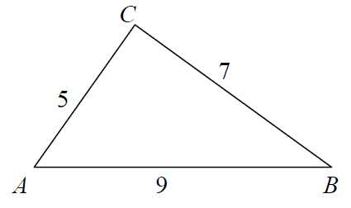
1. Find the area of each triangle below.
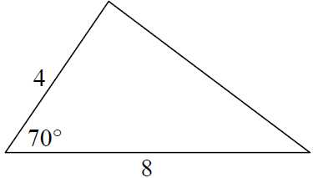
a. b.

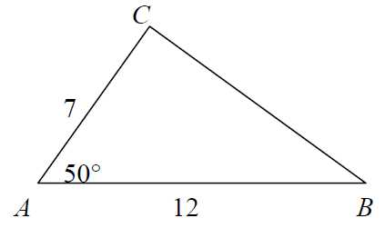
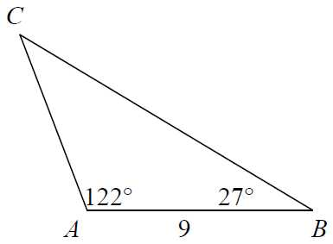
c. d.

2. A painter needs to cover a triangular region 75 m by 68 m by 85 m. A can of paint covers 75 m² of area. How many cans (round to the next higher number) of paint will be needed?

Lesson 4 Homework *Homework based on Periodic functions
Determine the amplitude and period of each function. Then graph one period of the function.
- y = sin 2x 2. y = -4cos(½x) 3. y = -3 sin 2x

Determine the amplitude, period, and phase shift of each function. Then graph one period of the function.
- y = sin(x – π) 2. y = cos (2πx + 8π)

Lesson 5 Homework
Graph two periods of each of the given functions.
- y = 3 csc x 2. y = 2 sec x 3. y = sec (x/3)

4. y = csc (x – π) 5. y = -(3/2) sec πx 6. y = csc (x – π/2)

Lesson 7 Homework
Give the amplitude and period of each function graphed below. Then write an equation of each graph.
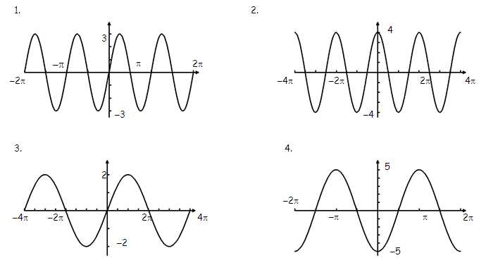

Lesson 8
1. Find a sine equation that fits these points: (0, 0), (1, 1), (2, 2), (3, 1), and (4, 0)

2. Find a sine equation that models the following data:

Lesson 9
1. Lilly is planting a triangular rose garden. The lengths of two sides of the plot are 8 feet and 12 feet, and the angle between them is 87°. Find the area of the garden.

2. If the vertex angle of an isosceles triangle measures 30° and each leg measures 4, find the area of the triangle.
3. Consider the table below which shows the mean monthly maximum temperature for Cape Town, South Africa. Find a sine model for the data.
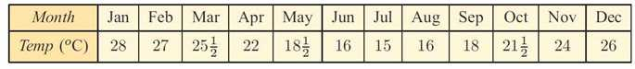

4. The population of water buffalo is given by $P\left(t\right)= 400+250sin⁡(90t)$ where t is the number of years since the first estimate was made.
a. What was the initial estimate?
b. What was the population size after 6 months? after 2 years?
c. Find P(1). What is the significance of this value?
d. Find the smallest population size and when it first occurred.
e. Find the first time when the herd exceeded 500.

