**Precalculus Unit 5 Notes—Graphing Sinusoids**

**Definition**: A function is a _________________ if it can be written in the form 🡪 *f* (*x*) = a•sin (b*x* + c) + d

(where a, b, c, and d are constants and neither a nor b is 0) **OR** *f* (*x*) = a•cos (b*x* + c) + d

**Definition**: The _________________ of a sinusoid of the form form 🡪 *f* (*x*) = a•sin (b*x* + c) + d **OR** *f* (*x*) = a•cos (b*x* + c) + d

is ____. Graphically, the amplitude is ____________________________________________.

**Definition**: The _________________ of a sinusoid of the form form 🡪 *f* (*x*) = a•sin (b*x* + c) + d **OR** *f* (*x*) = a•cos (b*x* + c) + d

is ____. Graphically, the period is the length of ____________________________________________.

**Definition**: The _________________ of a sinusoid of the form form 🡪 *f* (*x*) = a•sin (b*x* + c) + d **OR** *f* (*x*) = a•cos (b*x* + c) + d

is ____. Graphically, the frequency is the number of ____________________________________________.

Things to keep in mind . . .

* The basic graphs of sine and cosine have a period of 2 $π$.
* Changes in amplitude and period as well as phase shifts are nothing more than transformations you’ve seen before; they have just been given new names for trig functions.
* Changes in amplitude are vertical stretches or shrinks/compressions
* Changes in period are horizontal stretches or shrinks/compressions
* Phase shifts are horizontal (left or right) shifts
* These graphs can also be shifted vertically



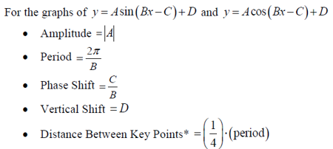

C:\Users\jpowell\AppData\Roaming\PixelMetrics\CaptureWiz\Temp\4.png

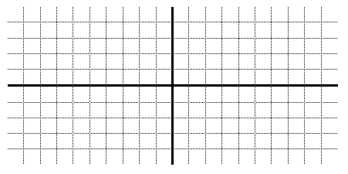Graph  Graph 



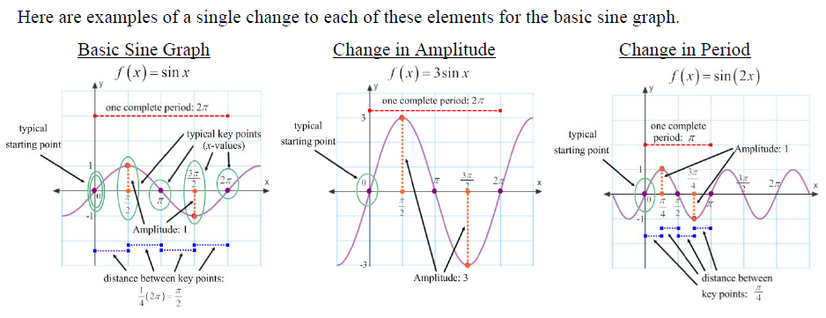

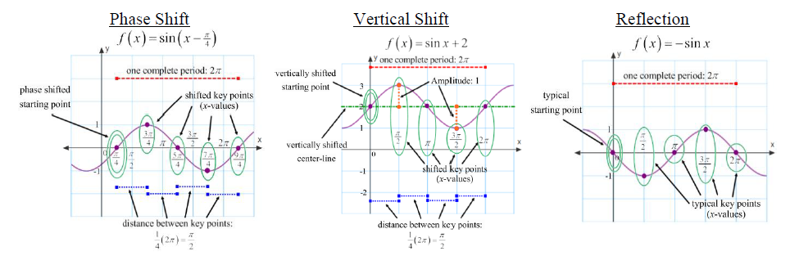

**Example 1** Find the amplitude of each of the following sinusoids & then use the language of transformations to describe how the graphs of b and c are related to a.

**a)**  *f* (*x*) = cos *x* **b)**  *y* = ½cos *x* **c)** *y* = –3cos *x*

amp = _____ amp = _____ amp = _____

**Example 2** Find the period of each of the following sinusoids & then use the language of transformations to describe how the graphs of b and c are related to a.

**a)**  *f* (*x*) = sin *x* **b)**  *y* = 3sin (–2*x*) **c)** *y* = –2sin

pd = _____ pd = _____ pd = _____

**Example 3** Find the amplitude, period, and frequency of the function *f* (*x*) = 4 sin. Sketch the graph.

|  |  |  |  |  |  |  |  |  |  |  |  |  |  |  |  |  |  |  |  |
| --- | --- | --- | --- | --- | --- | --- | --- | --- | --- | --- | --- | --- | --- | --- | --- | --- | --- | --- | --- |
|  |  |  |  |  |  |  |  |  |  |  |  |  |  |  |  |  |  |  |  |
|  |  |  |  |  |  |  |  |  |  |  |  |  |  |  |  |  |  |  |  |
|  |  |  |  |  |  |  |  |  |  |  |  |  |  |  |  |  |  |  |  |
|  |  |  |  |  |  |  |  |  |  |  |  |  |  |  |  |  |  |  |  |
|  |  |  |  |  |  |  |  |  |  |  |  |  |  |  |  |  |  |  |  |
|  |  |  |  |  |  |  |  |  |  |  |  |  |  |  |  |  |  |  |  |
|  |  |  |  |  |  |  |  |  |  |  |  |  |  |  |  |  |  |  |  |
|  |  |  |  |  |  |  |  |  |  |  |  |  |  |  |  |  |  |  |  |
|  |  |  |  |  |  |  |  |  |  |  |  |  |  |  |  |  |  |  |  |
|  |  |  |  |  |  |  |  |  |  |  |  |  |  |  |  |  |  |  |  |

**Example 4** Find the amplitude, period, phase shift, vertical shift, and any reflection.

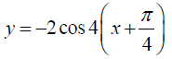

**Example 5** Find the amplitude, period, phase shift, vertical shift, and any reflection. Then graph one complete period.

C:\Users\jpowell\AppData\Roaming\PixelMetrics\CaptureWiz\Temp\29.png

A.

B.

C:\Users\jpowell\AppData\Roaming\PixelMetrics\CaptureWiz\Temp\28.png

C.

**Example 6 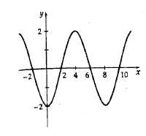**Write an equation in the form y = Asin(Bx) or y = Acos(Bx) for each graph.

A.

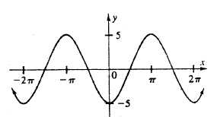

B.

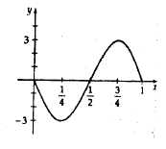

C.

**Example 7** Write an equation for each description or graph.

A. sine function; amplitude = 2, period = , shifted down 1 unit

B. cosine function; amplitude = 4, period = 3, shifted right  units, shifted up 2 units

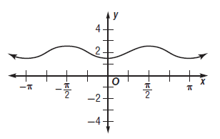 C. sine equation D. cosine equation

