Precalculus Unit 5 Notes—Trig Functions of any Angle

In Trigonometry we look at an angle in terms of a rotating ray. The beginning position of

the ray is called the __________________ side of the angle.

The ray is rotated about its end point called the _____________ and the final position of the

ray is called the ________________ side of the angle.

The __________________ of an angle is a number that describes the amount of rotation from the initial side to the terminal side of the angle.

Positive angles are generated by __________________________________________ rotations

Negative angles are generated by __________________________________________ rotations

***NOTE: Typically angles are drawn in STANDARD POSITION with vertex at the origin & initial side on the positive x-axis.

Because it is possible for two angles to have the same initial side and terminal side but different angle measures we refer to these angles as __________________ angles.

Ex 1) Find 2 positive and 2 negative angles that are co-terminal with the given angle.
a) 30° b) –150° c)

d) 300° e) –210° f)

reference angle -- the angle that the given angle makes with the x-axis. Regardless of where the angle ends (that is, regardless of the location of the terminal side of the angle), the reference angle measures the closest distance of that terminal side to the x-axis.
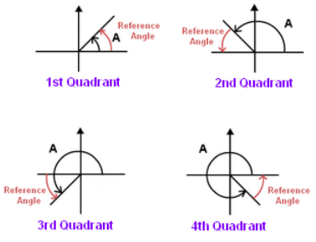

Ex 2) Draw each angle in standard position, and find its reference angle.

θ = 60° | θ = 135° | θ = 315°
θ = -30° | θ = 585° | θ = -342°

Ex 3) Let θ be the acute angle in standard Ex 4) Find the six trig functions of an angle
position whose terminal side contains whose terminal side passes through (-6, 8)
(5, 3). Find the 6 trig functions of θ.

Ex 5) Find the six trig functions of 315° Ex 6) Find each of the following:

a) sin(-210°)

b) tan(5π/3)

c) sec (-3π/4)

Angles whose terminal sides lie along one of the coordinate axes are called ______________ angles.

Ex 7) Find each of the following, if it exists:

a) sin(-270°) b) tan 3π c) sec (11π/2)

d) cos(180°) e) cot (0°) f) csc (–π/2)

Ex 8) Find cosθ and tanθ using the given information to construct a reference angle.
a) sinθ = 3/7 b) secθ = 3 c) cotθ is undefined
tanθ < 0 sinθ > 0 secθ < 0

Ex 9) Find sinθ and cotθ using the given information to construct a reference angle.
d) cosθ = –12/13 e) cscθ = –5 e) tanθ is undefined
sinθ < 0 tanθ < 0 sinθ > 0

